Annual Report Arab Educational Institute-Pax Christi
1/9/2020-30/8/2021

Introduction

The Arabic concept of sumud, literally steadfastness, guides the work at the Sumud Story House of the Arab Educational Institute, a Palestinian organization for community education in the occupied West Bank and affiliated to the international peace movement Pax Christi.
'Sumud' is sometimes symbolized as sabr or cactus: it relates to both the cactus’ capacity to endure and the sweetness of the fruit. AEI’s work aims at the development of community steadfastness/resilience with this double meaning of sumud in mind. Over the years, AEI has been working through community education and advocacy, the celebration of Palestinian culture and narrative, and the facilitation of local and international bridge building and exchange.

At the end of 2020, the Christmas tree was again lightened at Nativity Square in Bethlehem, a symbol of hope. Yet in 2020-1 the on-going coronavirus crisis and the occupation left once again a scar on the Bethlehem and Palestinian communities. The economy, especially tourism, was greatly affected. Public life became increasingly characterized by a lack of law and order, a surge in domestic violence, and a general atmosphere of hopelessness. At the same time, we noticed that many people, including youths, showed solidarity by supporting materially or symbolically other Palestinian citizens, especially those vulnerable and affected by the corona crisis. The ongoing Israeli occupation and creeping annexation through the expansion of settlements and the taking over of area C left an impact on many people’s livelihood, especially in the countryside. Apartheid is becoming a key term used by international human rights organizations to characterize the situation not just in the West Bank and Gaza but also that of Palestinians in Israel.

In the Sumud Story House, several women’s groups and a women’s choir came together for a variety of activities and courses, besides the activities of a kids group, a youth group, a teacher group and a faith group.

In 2020-21 AEI ran the following projects:

- Inter-religious citizenship education
- Sumud and peace advocacy
- Conflict education
- Early Warning and Response System in Hebron
- Providing information and raising awareness about the Wall
- Sumud Story House.

- Inter-religious citizenship education

Project Name : Citizenship and Diversity: Christian-Moslem Living Together
Project Duration : 01.09.2019 – 31.08.2022
Donors : Misereor, Kindermissionswerk, Missio, CAFOD, Solidarity Funds (Neth.).

Project short description: The project network of 30 schools helped to foster equal, responsible and participatory citizenship and respect for diversity. Christian and Muslim students, educators and parents joined the message of working together for the public good during the Covid-19 crisis.

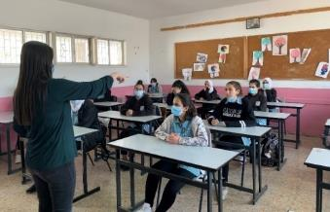
Officially the Ministry demanded a stop to all external projects. However, Ministry officials in both Bethlehem and Ramallah were aware of the program activities and were informed, directly or indirectly, of program implementation. They allowed all activities to continue as long as health protocols were fully observed and there were no parents and community objections. For instance, during an Iftar the Governor’s National Emergency laws and restrictions were discussed and an unanimous approval was agreed upon with strict abiding to organize meetings in large spaces, and to have social distancing, wearing masks, limited numbers of participants and sufficient time. This again showed the determination of AEI, the supervisory committee, and the teachers and students to continue with the project. The indirect acceptance of the Ministry showed they considered the project as vital and needed.

The joint Christmas feast celebration was in most of the participating schools replaced by small celebrations. Instead of the large Christmas meeting, a Christmas olive tree decoration together with lunch and interfaith gathering took place in the Sumud Story House garden in the presence of Fr. Rami Askrieh and the Mufti of Bethlehem Abed Al Majid Al ‘Amarneh.
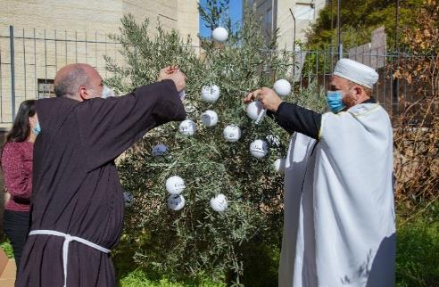
Instead of coordinated advocacy campaigns, individual schools organized advocacy initiatives in which the different meanings of sumud (spiritual, religious, educational and political) were translated to apply to the ongoing time, under the Biblical slogan, “Let not your left hand know what your right hand does”.

Corona required once again flexible and improvised planning, and listening well to teachers and Ministry officials. Teachers needed relevant online materials and training in using them. AEI’s separate enrichment project supported by a subsidy of missio was quite helpful here.

Results:

- 984 Palestinian school students in the regions of Bethlehem and Ramallah aware of commonalities, and respectful of differences between Islam and Christianity. 718 or around 73% of students delivered contributions with minimum good quality (essay, story, poem, drama performance, interviewing, research.
- 3 public activities in which Moslem-Christian living together was promoted.
- 60 teachers trained in applying student-centered methodologies of inter-religious/civic education in class; half of them designing a inter-religious lesson plan.
- Achieving broad community support for the project involving teachers and other religious and educational stakeholders (parents, informal leaders, imams and priests) as well as educational authorities (district offices Bethlehem and Ramallah, headquarters Ministry of Education in Ramallah).
- 27 school-based advocacy actions organized to spread the project message, with over 2000 attendants in total.

Additional projects

AEI conducted a series of interviews with Moslem and Christian personalities about A Christian-Islamic Religious Vision on the Concept of Sumud in Times of Covid-19 Crisis, supported by KAICIID (international dialogue center, Vienna). Here is the interview with Rania Murra, AEI’s director.

A subsidy of German funder missio made it possible to develop a website on inter-religious education in the context of the COVID pandemic, including:
  - YouTube films
  - Online games
  - Power Points
  - Model lessons and other teaching materials.
The Arabic webpage on the project is accessible through this link: https://aeicenter.org/ar/citizenship-and-diversity-ar/
The joint inter-religious lessons in the Citizenship and Diversity project have become richer in methodologies and also more relevant to students given the influence of the pandemic upon people’s lives. The moral dilemmas as worked out in the PPs and online games challenged students to think for themselves through morally complex situations. Moreover, using mobiles for playing educational games is a new and interesting experience for students. It is important for AEI, in order to sustain impact and keep youths interested, to improve the contents and presentation of the existing games and add new games to the online game platform in the future.
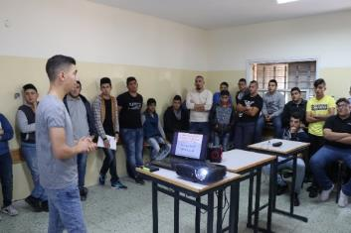
During the emergency of the pandemic, voluntary cooperation happened between private and governmental schools. Some private schools participated with government schools in distributing dates and water during Ramadan as well as during the feast of St. Barbara. In general, teachers from different background liked to come together during training sessions and other encounters such as joint celebrations. Also, teachers from the schools appreciated AEI as a body which brings the different types of schools together in front of the Ministry of Education to highlight the problems in the Palestinian curriculum and the difficulties in the teachers’ work.

- Sumud and peace advocacy

Project Name : Engaging, empowering and equipping diverse and marginalised youth and amplifying their voices for peace
Project Duration : 15/1/2018 - 15/3/2021, with additional months for evaluation.
Donors : EUPI and CAFOD.

Project short description : Locally coordinated by AEI, 20 Palestinian schools and youth/women clubs in the southern West Bank contributed to a community advocacy project for Palestinian youth. Supported by the EU Peace Initiative and the British charity CAFOD, youth and women groups in both the Bethlehem and Hebron areas raised their voices in front of local decision makers. The project promoted civil society engagement in non-violent action for a just peace.
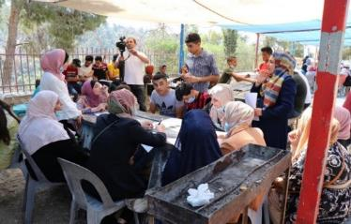
A mixture of 600 school-age teenagers and young women up to 35-years-old became active in their communities In the Bethlehem and Hebron areas after a training in advocacy, communication, and international law. The training helped the young women and school youth to successfully lobby for better access to services, more effective waste management in their communities, and most importantly during the pandemic, to contribute towards the provision of new health clinics. A social media story series developed by the women and teenagers stressed social and political justice, highlighting the need for women to have equal rights in Palestinian society.

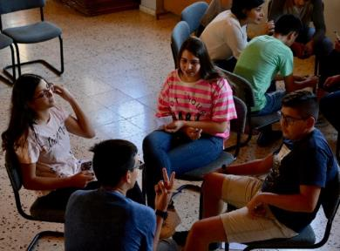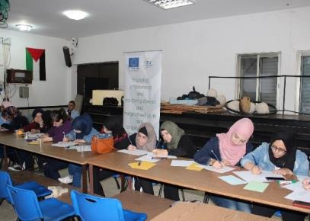
Due to the corona virus crisis, planned in-person activities like the national conference in Hebron and the advocacy campaign events in both Hebron and Bethlehem could not be organized as planned. The national conference and advocacy campaigns in the Hebron area were combined and held in two large open-air meetings, one in Dura and one in Hebron. In Bethlehem the national conference was held in a decentralized way, in each of the communities separately. The number of fieldtrips was reduced due to corona, and instead more online visibility activities were organized. Through the simulation game previously developed, the youths in the Hebron area learned about the various advocacy steps: how to approach peace, conduct networking, organize a public action, and involve media.

A major outcome of the campaign activities and the fieldtrips was the generation of social energy to participate in positive non-violent action in support of “rights and services,” especially so in view of the public health and mental health crisis and the economic needs that emerged during corona time.

Especially the young women were active during the third year in taking elaborate non-violent actions for peace, such as in Artas, Aida camp, Sumud Story House and the five communities in H2. The lesson is that such women, when brought together and supported by strong trainers and facilitators and CSOs, can generate much energy and hope among themselves and in the community. When the broader community encourages them, they have the skills and networks to bring things into motion. In all the activities, AEI made the link between rights and needs on the one hand, and the concepts of sumud and peace on the other.

In addition, 275 personal narratives were collected in the project over the three years, 90 during this last year. The stories were differentiated between stories of ‘conflict’ and ‘hope’.

Two voices:

- “Today I will reveal a story of struggle and difficulties that I went through. I am a married woman, and have two sons. My husband had an accident that led to a severe injury and caused him a disability. He no longer works. We live in a bad condition on the financial and psychological level. I would lose myself from time to time. I referred to help through an institution, but got no help. I started my own business but failed. Fortunate enough, a friend of mine introduced me to the waste management campaign, sponsored by the Arab Educational Institute (AEI). To be honest, I only wanted to participate in the campaign with the intention to get help from the Institute. By the first meeting, I learned many good things. I was trained on how to define a problem, ways to solve it, how to communicate with decision makers, communication skills, capacity-building. Further, success stories were introduced in which I was able to realize and define my own weaknesses and good points. When I was done with the campaign, I was able to re-start myself and renew my business [pastry making], which once failed. I have become able to raise my family without the need of anyone. I was influenced by the facilitator Maysoun Qawasmeh and used social media as a tool to expand my business further. Nowadays, I have become a successful business woman.

- Since my childhood, I love poetry and writing a lot. I have volunteered in many institutions and centers such as Al Ruwaad Center, Shorouk Foundation, Refugee Center, and Aida Youth. I have participated in many different programs in various fields. I have been looking for an institute interested in literature and creative writing, but I did not find it. I developed myself with the support of my family and the school, and I published my first book at the age of 14, but this dream always remained in me. I entered Bethlehem University and studied Arabic literature. At that time I was participating in the project “Palestinian Youth: Sumud and Advocacy” which encouraged me and pushed me to take an initiative in the community. One day, I launched my initiative called: "The literary salon” at schools and universities. My initiative aimed at sharpening talents, host writers, discuss novels that address social issues, and organizing poetry evenings. After the great success of my initiative, I discovered that it is a social need, not just my dream. In the first introductory meeting, 50 students came to me. Today after a year of working hard and after developing this idea it has become a cultural institute called "Al-Manar Institute for Culture and Creativity", and it contains programs for children, youth and women. I want to thank the AEI and the EU for their support and urging us as young youth to take a community initiative. Without them, I would not have started my cultural institute.

An external evaluation of the project on AEI’s side was conducted by Mr George Akroush (Jerusalem).

For photos and stories:
The project’s stories and photos in the instagram series – “sumudstories” – see here.
- Conflict education

Project Name : Palestinian Youth Protecting Civic Values in Conflict
Project Duration : 01.09.2018 – 31.12.2020
Donor : ifa – Institut für Auslandsbeziehungen (zivik Funding Programme, Federal German government)

Project short description: The project “Palestinian Youth Protecting Civil Values during Conflicts,” supported by the German Federal Government (ifa) involved 8 government schools in the Bethlehem district: Battir, ‘Abediyyeh, Artas, Beit Jala, Aida Camp, Doha, and Dar Salah. They worked on upholding civic values in the context of various types of conflict. 400 youth studied tensions and conflicts within or imposed upon their communities. They carried out advocacy initiatives and raised their voices and demands in front of public figures.

During planning meetings in each of the 8 communities a conflict focus within the overall annual theme of „conflicts about land and water use“ was chosen, with students of the previous project year present to share their experiences.

Guided by educational leaders and various local figures, the youths of 15-17 year conducted a story research that resulted in an Arabic-language book accompanied by a card game. The publication was developed with a selection of 40 inspiring stories of respect during conflict sequenced according to the following guiding values:

- Spirit of sumud or steadfastness
- The importance of the strength of family and community in dealing with conflicts
- The value of neighboring, including Moslem-Christian living together
- Valuing land and water in the West Bank
- Taking precautions in dealing with the corona virus crisis.

The card game was developed with the use of the most inspiring stories.

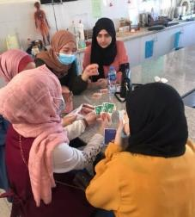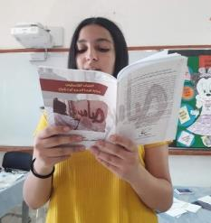
During a Day of Respect in the late summer, the different school communities raised local publicity and attention to their advocacy issue. The final December conference, “Respecting the People and the Land in Times of Conflict,” was spread out over four days, so as to prevent a large gathering, and was held in the open air. The audience was formed by delegations and student groups from 8 visiting schools that had already been in online contact with the project schools. In total 240 students participated from the project schools and the visiting schools, and 32 teachers/youth leaders. Other attendants included staff and head of the Bethlehem district office of the Ministry of Education, along with media personalities and AEI staff.

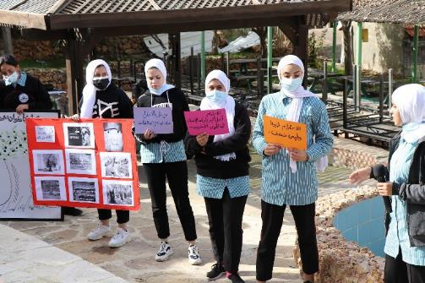

Several evaluation meetings afterwards showed that the youths have become more analytical in understanding crises and conflicts, more constructive-critical with regard to the behaviour of authority bearers, and more patient in looking at ways of dealing with conflicts including the type of responses towards anger and problems in general.

An external evaluation was conducted by Mr Usama Khalilieh.

- Early Warning and Response System in Hebron

Project Name : Palestinian Women operating early warning and mediation systems to prevent conflicts in Hebron H2
Project Duration : 15/05/2020 - 14/11/2021
Donor : Women Peace and Humanitarian Fund/UN Women

Project short description: A new AEI project, “Palestinian Women Operating an Early Warning and Mediation System to Prevent Conflicts in Hebron H2” aimed at developing and operating an Early Warning and Response System (EWRS) on local conflicts in downtown Hebron.

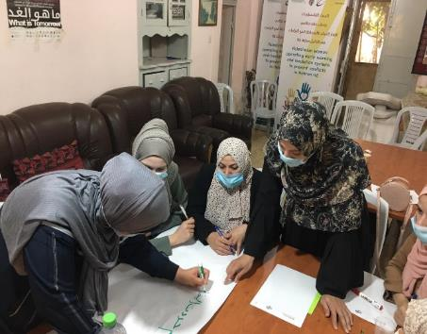
The project, led by AEI as lead applicant and Women’s Activity Association (WAA) as co-applicant, had as outcome the participation of women in conflict prevention in H2 Hebron. Dealing with violence against women and domestic violence is an important aspect of the conflicts the project attempted to prevent or deal with. Hebron downtown is much affected by the presence of Israeli settlements which directly impact on women’s lives and their chances to participate in society.

On the ground the project was implemented by 5 early warning teams of 8 women in 5 different Hebron H2 neighborhoods. The early warners were supported by 5 responder/mediator teams of 20 local women per neighborhood, all volunteers.

In total 40 early warners (8 per CSO) were trained over 8 sessions, and 100 mediators (20 per CSO) were trained over 6 sessions in conflict sensitivity, mediation, communication, and other relevant topics. The teams of volunteers were supported in each of the neighborhoods by 5 local women CSOs. In order to train the groups of early warners and mediators different versions of a manual were developed. Five radio episodes were broadcast live on the local station Al-Huriya and were published on Facebook. In 10 training sessions, 10 staff of the partner CSOs enhanced their capacities to conduct strategic planning activities, proposal writing, and M&E, in order to strengthen accountability and representation when working on conflict prevention.
AEI, WAA and the 5 CSOs collected no less than 980 cases of which 200 have been reported online and uploaded on the website www.ewcs.ps using the code “EWRS”. Moreover, 39 cases were selected for responsive intervention and 90 cases were referred to local women mediators and responders. The highlighted conflict cases concerned civil peace, drugs, violence and family incest. They became the subject of 4 communication workshops for the Hebron communities involved.

- Information and awareness-raising about the Wall

Project Name : Wall Information Center
Project Duration : 01.04.2019 – 31.03.2022
Donor : Haella Foundation and Friends of Young Bethlehem

Project short description : The Wall Information Center at AEI’s Sumud Story House in North-Bethlehem aims to give voice to Palestinians who are directly hurt by the so-called separation wall. It provides information about the impact of the wall toward domestic and international audiences and gives attention to people’s narratives of loss as well as their sumud [steadfastness, resilience]. Doing so it amplifies the voices of Palestinian women living in the shadow of the wall.

Various small events were organized along the Wall, including

  - interfaith prayers and moments of reflection during the World Week for Peace in Palestine Israel in Autumn 2020
  - a drama performance by AEI’s staff in the context of a news item about the Palestinian nakbeh (flight and expulsion of Palestinians in 1948), in cooperation with the Bethlehem Bible College media program.
  - Some kids reciting wishes and prayers in front of the Wall on the occasions of Easter and Christmas.
  - Children making symbolic photos about peace and justice in front of the wall as part of the weekly kids’ group meeting in which they talked about the concept of peace.

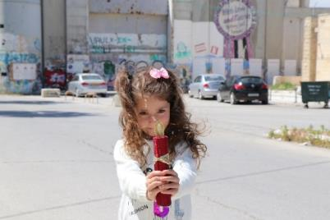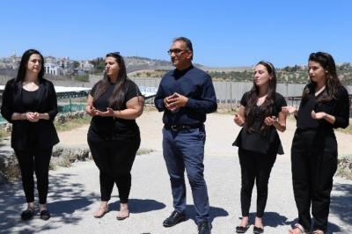
A Human Rights Path along the 8-9 meter high wall near SSH was this year developed as a concept. It was decided to focus on the situation of Palestinian children.

AEI collected photos and brief videos about “challenging the difficulties” (during corona time) taken by some 30 women, youth and kids groups’ members. The videos and photos showed how the members face political and health challenges. They covered subjects and activities like planting the land, inspiring beautiful flowers, singing, cooking, and writing quotes and reflections.

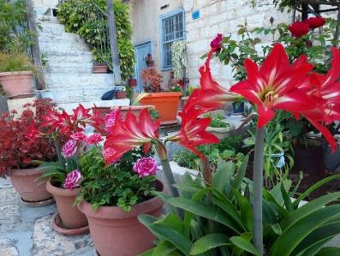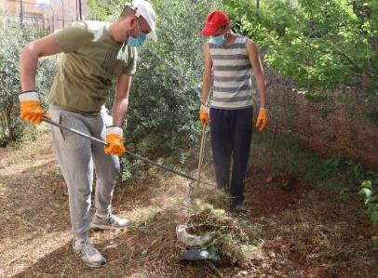

AEI staff made a brief film about the “Ongoing Nakbeh” showing the impact of the Wall: https://www.facebook.com/100055505071269/videos/272711081255726/

They prayed with Rev. Jack Sara of the Bethlehem Bible College at the occasion of the Nakbeh commemoration: https://www.facebook.com/100055505071269/videos/272711081255726/

Staff member Claudette wrote a personal article, Out of the Cage: https://aeicenter.org/out-of-the-cage/

Toine van Teeffelen wrote for the Jerusalem Quarterly about “Rachel’s Tomb: Narrative counterspaces in a Military Geography of Oppression”, published at the end of 2021.

AEI accepted to be co-publisher of Gied ten Berge’s English translation of his PhD: “Pilgrimage with a Mission”, about Come and See pilgrimages to Palestine including to the Rachel’s Tomb area. At the occasion of this translation a webinar was held by Tilburg University in Spring 2021 to which Toine contributed a paper about “Come and See pilgrimages as a hope-giving practice”, published on academia.edu and AEI’s FB page.

About the Wall Museum, with a link to photos of posters:
https://aeicenter.org/?page_id=94
For a reading of story wall posters:
https://aeicenter.org/wp-content/uploads/2019/10/AEI-2019-resource-wall-posters-all.pdf

- Sumud Story House

Project Name : Sumud Story House
Project Duration : 01.09.2019 – 31.08.2020
Donors: Quakers NL, EU/CAFOD

Project short description : The Sumud Story House is located near the Bethlehem-Jerusalem checkpoint and the Wall around Rachel’s Tomb. Rachel’s Tomb is a holy place in north Bethlehem annexed to Israel and walled-off, made inaccessible to Palestinians. At the Sumud Story House 2 women groups, a choir, and youth and faith groups, came regularly together for their weekly meetings dealing with a wide range of social, cultural, psychological and religious topics. The women groups have a mixed Moslem-Christian composition, and focus on community building and developing voices and stories. The particular strength of the SSH is the opening up of platforms in which common women, Moslem and Christian, meet, dialogue with, and sometimes challenge authority representatives. Religious stakeholders like sheikhs and priests have become conveyors of the House’s message in support of gender equality.

Many of the stories shared by the women and youths of the Sumud Story House have appeared on the nearby separation wall in the form of wall posters, embracing a sense of never giving up and of striving to create a brighter and more peaceful future for themselves and their families.

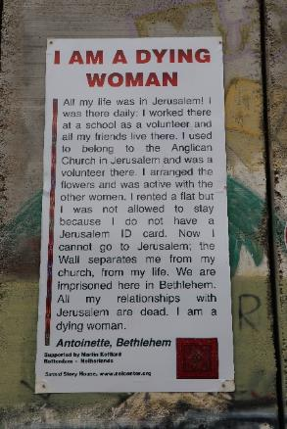

Seven training sessions (online and offline) took place with a SSH women’s group (25 members) on subjects related to the impact of the wall, like narrating stories, the latest political and human rights developments around the Wall, prayers for people suffering from the occupation, writing wishes and documenting life stories of some women about sumud.

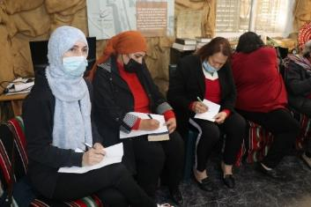
Some 40-50 members from the youth and women's groups, supported by AEI staff, helped to distribute gifts to promote people's sumud during corona time, especially at Christmas.

The proceeds of last year's Christmas lottery organized by the Friends of Young Bethlehem in the Netherlands were used by AEI for a series of lively sessions on the theme of 'trauma', in collaboration with the youth group and two young women's groups. A qualified psychologist, Sandrine Hilal, director of the “Psychology Today” Institute in Bethlehem, led the 15 workshops with titles such as “How Do You Act When You Are Angry?” “Tolerance helps get you out of the prison you sometimes put yourself in.” “How can we deal with personal problems?” “How to transcend inner walls?” “Leave the difficulties behind and start your life again!” “The steadfastness of Palestinian women and their role in the community.” The sessions were attended by a total of 45 youth and young women.

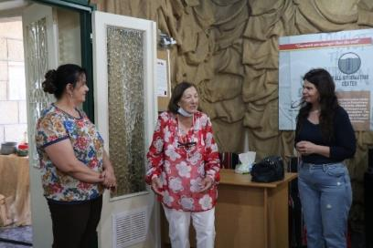
Finally, AEI staff received a series of training sessions about monitoring and evaluation given by the Jerusalem-based trainer George Akroush as part of CAFOD’s support for AEI’s capacity building.

- Other

Networking

AEI is a networking organization, and in 2020-21 was linked up to various organizations:

- Pax Christi, of which AEI is a member organization.
- UNOY Peacebuilders, with its network of 80 youth organizations in 50 countries.
- World Week for Peace in Palestine and Israel, convened by the World Council of Churches.
- Kairos Palestine and Sabeel and its new initiative Kumi Now which devoted an episode on the Wall Museum.
- Christian organizations in Palestine, coordinating political positions and statements, of which AEI is presently secretary.
- Arigatou, an international organization for inter-religious dialogue and living together.

Locally, AEI maintained and developed networks in the central West Bank and the Hebron area among schools, women organizations and cultural or youth clubs.

AEI also took part in a committee with inspectors of the Ministry of Education and Higher Education in overseeing inter-religious education at about 30 schools, both governmental and private, in the context of the Citizenship and Diversity program.

AEI developed its internal capacity to conduct innovative actions for justice and peace:

- 4 trainers and facilitators joined the AEI board and have now an important advisory function within the organization, especially Maysoun Al-Qawasmeh, who became chair of the board.
- AEI’s network in the Bethlehem and Hebron/Dura regions was considerably strengthened, also because all the communities worked with their own configuration of stakeholders and approached different decision-makers. The support of the Ministry of Education has widened as well, now including the Dura region.

Advisory board

The board members represent the broader community and educational leadership: Zuheir Tinezi, Maysoun al-Qawasmeh, Widaad Rabi’eh, Anton Nassar, Sana’a al-‘Azza, Manar Ateek, Dr Sliman al-Lucy.

Permanent staff

Name permanent staff | Type of involvement in AEI | Qualifications
Fuad Giacaman | Co-president and political and educational adviser, program coordinator, member financial committee, monitoring and evaluation, member management team. | Former headmaster and teacher at Bethlehem schools, former AEI general director. BA in English language and literature.
Elias Abu Akleh | Co-president and financial adviser, program coordinator, financial management and accounting, member financial committee, member management team, monitoring and evaluation. | Experience in financial administration of dozens of AEI projects as well as private schools in Bethlehem and Jerusalem, involved in AEI since mid-1990s.
Rania Murra | General director, program coordinator, adviser on political and women’s affairs, spokesperson, member financial committee, monitoring and evaluation, member management team. | 10 years’ experience in setting up and coordinating women groups. MA in women and development studies. Presently member of international board Pax Christi.
Roger Salameh | Project coordinator, member management team. | Experience for over 8 years in youth projects, coordinating and secretarial work, coordinating AEI youth groups, international exchanges.
Claudette Mubarak | Project coordinator Wall Information Center | New BA graduate from Bethlehem University.
Toine van Teeffelen | Educational adviser and researcher, project manager. | Experience in developing, monitoring and evaluating of projects at AEI and elsewhere, author of teacher manuals and books and articles on Palestinian daily life, culture and identity. Ph.D. in discourse analysis, MA in social anthropology.

AEI’s staff and management met weekly. Workshops as part of staff meetings created in-depth communication on issues of implementation and learning processes. In such workshops issues of management, M&E, and conflict environments were discussed, as well as procedures for youth and children’s rights protection and complaints, among other things.

